Power BI Assignment 2 – DAX & Data Visualization
RESHMA V M

Calculated Columns:
- Create a Calculated Column for 'Category Type': Add a calculated column in the Order Details table that combines the 'Category' and 'Sub-Category' columns into a single 'Category Type' column.
- Calculate Revenue per Order in Order Details Table: Create a calculated column in the Order Details table to compute the revenue (Amount * Quantity) per order.
- Create a Calculated Column to Categorize Sales: Add a calculated column named ‘Sales Category’ in the Order Details table that categorizes each order as 'Above Average' or 'Below Average' based on the Amount value.
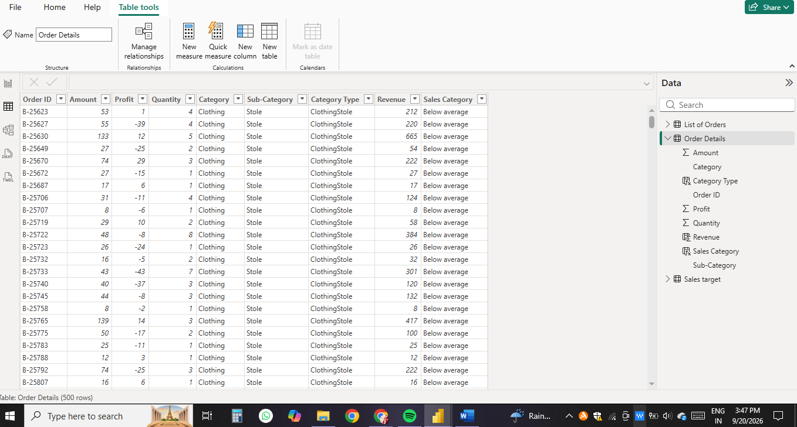

Pic: Calculated columns

Calculated Measures:
- Calculate Order Count: Define a measure to count the total number of orders in the Order Details table.
- Calculate Average Profit in Delhi: Create a measure to calculate the average profit for orders placed in Delhi.
- Calculate Year-to-Date (YTD) Sales: Define a measure to calculate the total sales amount accumulated from the earliest order date up to each order date.

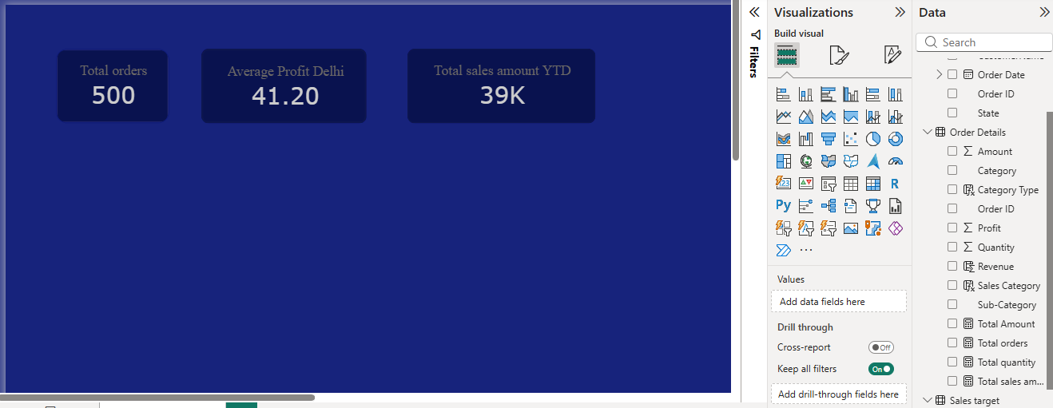
Pic : Calculated meassures

Data Visualization:
- Sales Target Achievement by Category: Compare actual sales with sales targets by category using a clustered column chart.

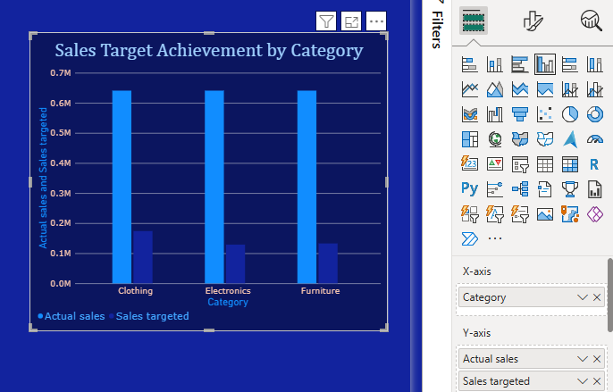
Pic: Clustered Sales Target Achievement by Category

- Max Profit Margin by Sub-Category: Analyze the maximum profit margin for each sub-category of products using a donut chart.

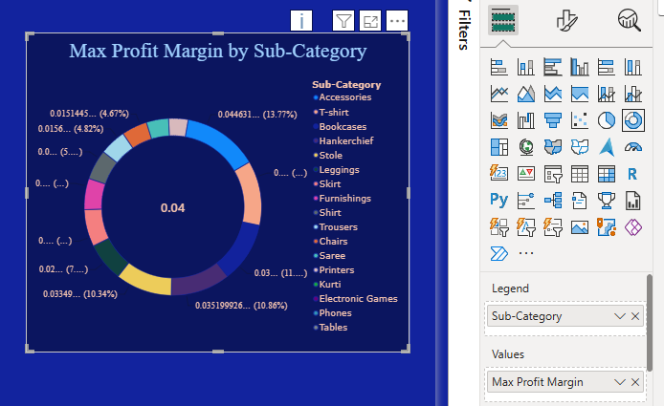
Pic: Donut chart

- Monthly Sales Trend: Show the trend of monthly sales over time using a line chart.

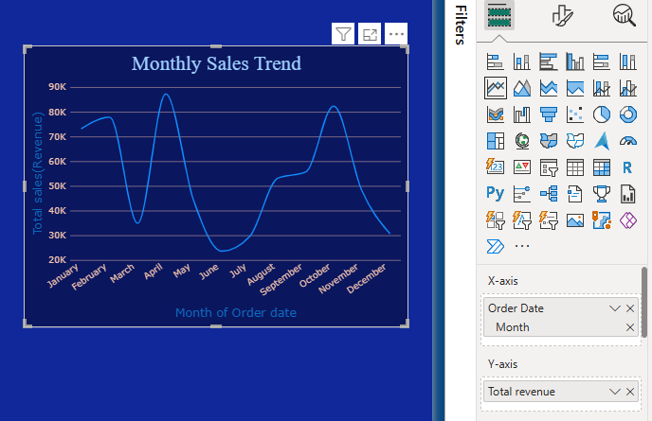
Pic: Monthly Sales Trend Line Chart

- Comparison of Profit and Quantity by Sub-Category: Compare the relationship between profit and quantity sold for different sub-categories using a scatter chart.

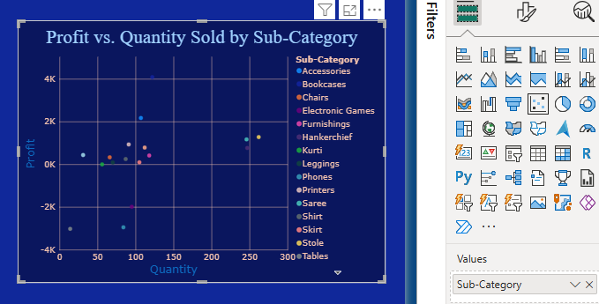
Pic: Scatter Chart: Profit vs. Quantity Sold by Sub-Category

- Comparison of Total Sales Amount and Target: Create cards to succinctly display the total sales amount alongside the sales target for quick comparison and analysis. Also, create a multi-row card to display the minimum target for each segment.
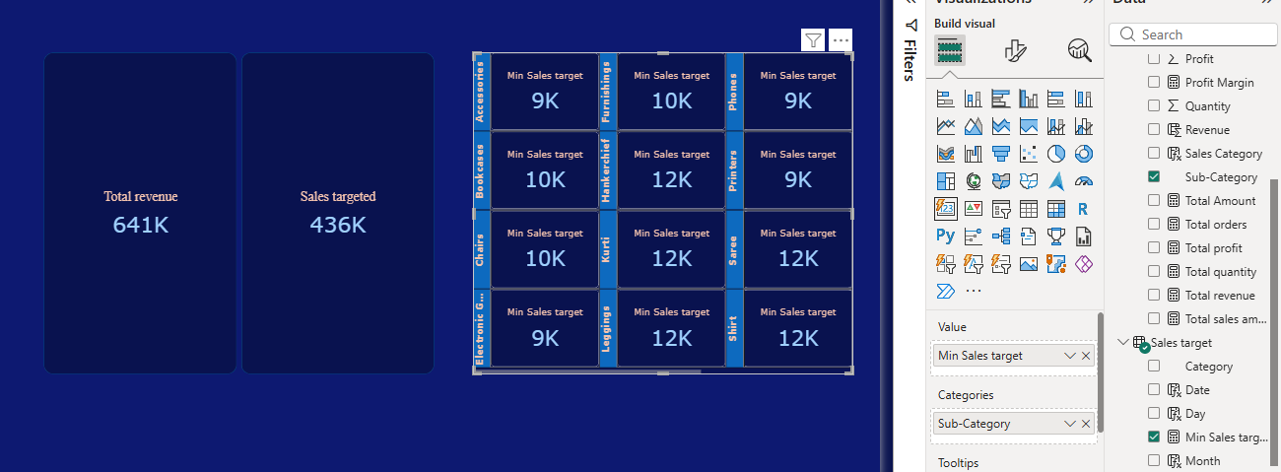

Pic : Card & Multicard related to target

- Sales Performance Matrix: Build a matrix view to analyze how actual sales compare to sales targets across different categories and months.

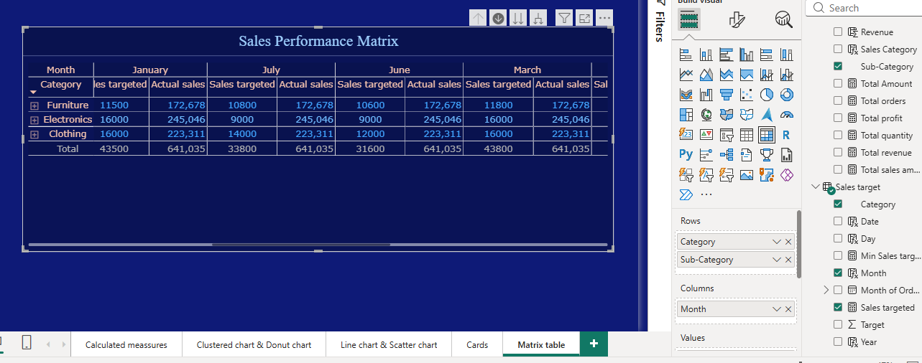
Pic : Sales Performance Matrix

- Geographic Sales Analysis: Visualize total sales on a map by city to identify regional sales patterns.

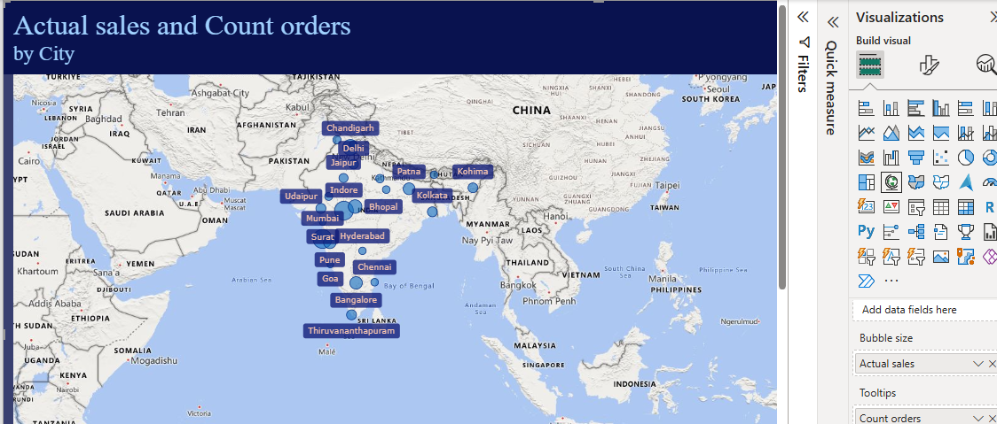
Pic : Geographic Sales Analysis by City

- Sales Distribution by Sub-Category: Represent the sales distribution across different subcategories using a treemap.

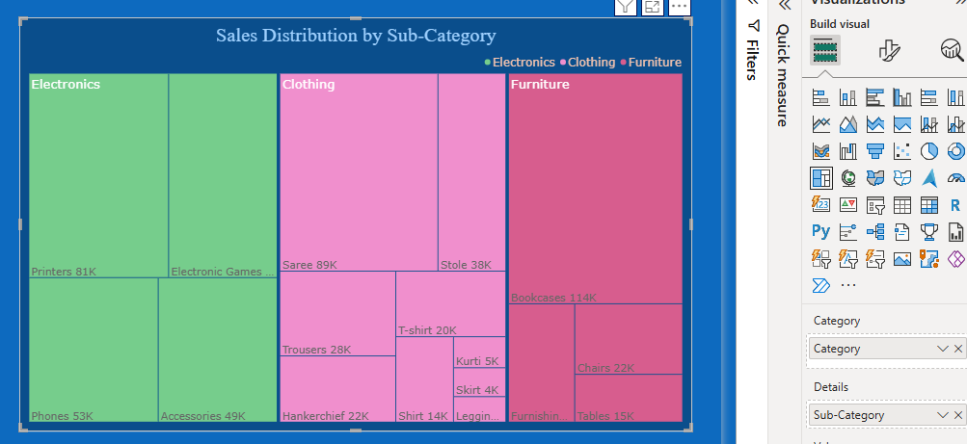
Pic : Tree map-Sales Distribution by Sub-Category

- Order Count Analysis by State: Create a funnel chart to visualize the distribution of order counts across different states.

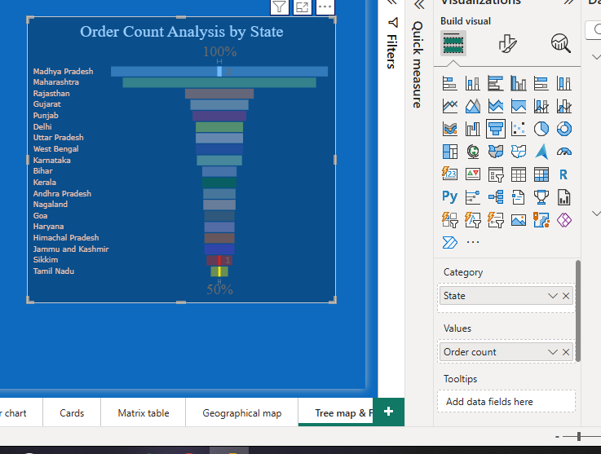
Pic:Funnel chart- Order Count Analysis by State

DAX (Data Analysis Expressions) is a formula language used in Power BI to perform calculations and analyze data. It is mainly used to create measures, calculated columns, and tables.

